fbneo-combo-trials: User’s Guide/Documentation
This document is intended to be an in-depth breakdown of the features of this script, covering basic usage, configuration, trial-specific functions and formats of trial & character data. If you’re willing to add to or change the content of this script (such as trials), read this document before doing anything else.
Running The Script
To run the script, you will need the following:
- The FBNeo emulator, preferably the version built into Fightcade.
- A supported rom of a supported game. For the list of supported games & roms, check the “gamelist.ini” file and the game-specific documentation.
- The fbneo-combo-trials script, the documentation to which you are currently reading.
Having all of this, do the following:
1. Run a supported rom of a supported game in FBNeo.
2. Check that there are no missing files & no errors in the configuration files or trial data.
3. Start a 2 player versus match.
4. In the top of the emulator window, select “Game – Lua Scripting – New Lua Script Window”.
5. In the newly opened window, press the “Browse” button. Select the file “fbneo-combo-trials.lua” and press the “Run” button. If the script does not return an error, you have successfully run the combo trial functionality.
The script features an error handling system to catch any errors in the config & data files that may arise. Most are self-explanatory and show you the exact locations of said errors. For more in-depth information on those files, see the “Configuration” and “Trial Data” sections below.
Lua hotkeys can be used to access a graphical menu which allows you to select different trials and change whether the trial list displays the names of the attacks or the inputs needed to perform them.
Some limitations:
- The script loads the character data & trials for both players’ currently active characters at the time of running. Changing characters in the middle of execution will break the trial logic. If you need to select the trials for a different character or perform them against a different opposing character, you must start a match with those characters and restart the script. There are no plans to change this at this time.
- Use of savestates is highly discouraged and does not guarantee proper execution of the script. The script doesn’t carry over any data pertaining to its operation when you load a savestate. It won’t break the script, but your loaded data and trial progress will not be saved with the savestate. There are currently no plans to change this.
Configuration
Configuration is done through the “default_config.ini” file in the script’s main folder and the “config.ini” files in the game folder. Both files are generally required for the script to run properly. In the event of any parameters overlapping, said parameters will be set in accordance with the game-specific configuration files.
The specific config parameters are described in the table below. Any deviation from the list of possible values will result in the script returning an error message at startup.
Parameter | Type | Description | Possible Values
MaxRefillTimer | Integer (frames) | The length of the interval for running the refill routine for both players’ health and meters. | Any integer >= 0.  Default: 120
TrialMaxLines | Integer | The maximum amount of lines able to be displayed in the trial list at once. | Any integer >= 0.  When set to 0, the entire trial list will be displayed at all times regardless of trial progress.  Default: 10
TrialScrollingStart | Integer | The number of actions needed to be completed before the trial list begins scrolling. | Any integer >= 0. Must be less than TrialMaxLines unless TrialMaxLines is set to 0.  Default: 5
AllowLineCarry | Boolean | If this value is set to true, allows using the “carry” flag in the trial data to display multiple actions on a single line. | true/false  Default: true
DisplayDebugText | Boolean | If this value is set to true, debug text will be displayed while the script is active. | true/false  Default: false
GUIHeaderPosX  GUIHeaderPosY | Coordinates | The coordinates for displaying the name of the current trial on the screen. | Any integer >= 0 within the screen dimensions (unique to each arcade hardware, shown in game-specific docs).  Example: if a game’s screen resolution is 384x224, then the X position must have a value from 0 to 383, and the Y position a value from 0 to 223.  (0,0) denotes the top left corner of the screen.  Default values are different for each game.
GUISuccessPosX  GUISuccessPosY | Coordinates | The coordinates for displaying the success message when a trial is completed.
GUIListPosX  GUIListPosY | Coordinates | The coordinates for displaying the start of the trial list.
DebugTextPosX  DebugTextPosY | Coordinates | The coordinates for displaying the debug text whenever DisplayDebugText is set to true.
GUIListInterval | Integer (px) | The vertical space between lines in the trial list. | Any integer >= 7 within the screen dimensions (unique to each arcade hardware, shown in game-specific docs).  This value must not be higher than GUIListPosY and the sum of this value and GUIListPosY must be within the screen dimensions, otherwise the entire list will be off-screen and the script will return an error.  Default: 7
GUIScrollMarkerInterval | Integer (px) | The horizontal space between the trial list and the arrow markers indicating the scrolling of the trial list. Scroll markers are displayed to the left of the trial list. | Any integer >= 0 within the screen dimensions (unique to each arcade hardware, shown in game-specific docs).  Must not be above GUIListPosX, otherwise the scroll markers will be off-screen and the script will return an error.  Default: 10
GUISuccessText | String | The text string to display when a trial is completed. | Any non-empty string in double quotes except “true” or “false”.  Default: “Complete!”.
GUIDefaultColor | Color | The color to display non-completed actions in the trial list. | Any number or one of the following strings:  “clear”, “white”, “black”, “gray”, “grey”, “red”, “green”, “blue”, “yellow”, “cyan”, “magenta”, “purple”, “teal”, “orange”, “chartreuse”.  Numbers are treated as 32-bit hexadecimal numbers in the format 0xRRGGBBAA.  Any floating or negative numbers default to 0 (“clear”).
GUISuccessColor | Color | The color to display completed actions in the trial list.
MenuDefaultTextColor | Color | The color to display the text of non-highlighted elements in the graphical menu.
MenuHighlightTextColor | Color | The color to display the text of highlighted elements in the graphical menu.
MenuDescriptionTextColor | Color | The color to display the description of the highlighted element in the graphical menu.
MenuInputHelperTextColor | Color | The color to display the text describing the buttons for navigating the graphical menu.

Character Data
When the script is run, it loads additional data for both players’ active characters at the time of running. This data is contained in the files in the “char_data” folder which is inside of every game folder. Each of these files contains a table of specific memory values that the script uses to detect what a character is doing at any given time, whether that be standing still, performing a specific attack, getting juggled, recovering from a knockdown – pretty much everything. Let’s take a closer look:
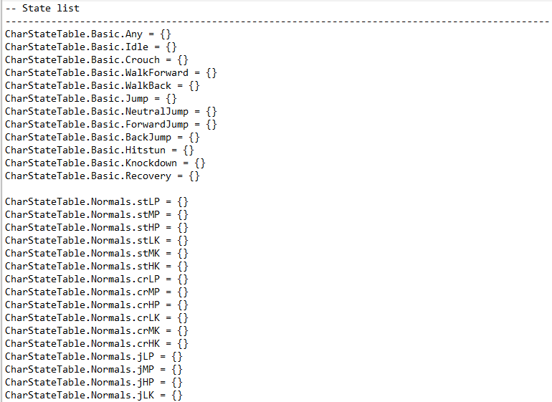
Every such file is made up of states. A state, simply put, is any single specifically defined thing that the character is capable of doing. In almost all cases, every single attack in a character’s moveset has its own state. Certain specials and supers may have several states – for example, if an attack has multiple followups (ex: Guy’s run) or certain parts that must be specifically defined because of logical constraints (ex: the ending part of Rose’s Aura Soul Throw super). A state must also be defined to detect if a character is in hitstun or in a knockdown state – this is done to accurately detect where a combo begins and ends for the trial logic to work properly.
In the screenshot above, you can see the start of the character’s state list. This is a reference point for all of a character’s states and the names by which they are called. When creating your own trials, you will need to construct a trial out of these states using their respective names (see “Trial Data” section for more details).
Here is what the inside of a state definition looks like. We will use Ryu’s sweep in Street Fighter Alpha 1 as an example:
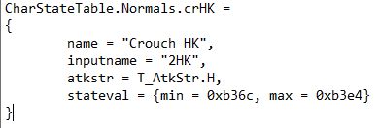
Inside the script, each state is a table of values which are read from memory and used by the trial logic while the script is active. Two of these are universal across every game supported by the script:
name (required): The name of the state. This will be displayed in the trial interface while the script is active. Must be a non-empty string.
inputname (optional): The command needed to perform the attack. This will be displayed in the trial interface if the appropriate setting is turned on. Must be a non-empty string. If not defined, name will be displayed instead.
The last two values are game-specific memory values used to detect the attack. They are different across most games because different games have different memory values that can be used to enforce the trial logic. You can read more about them in the game-specific documentation.
WARNING: Do not modify these files unless you know exactly what you’re doing & have experience with gathering data on the specific values inside the files. Any error inside these files will almost certainly break the trial logic for any attack where it is present.
Trial Data
This is most likely why you’re reading this.
When the script is run, it loads the trial data for player 1’s currently active character at the time of running. This data is contained in the files in the “trial_data” folder which is inside of every game folder. Each of these files contains a table of the respective character’s trials. Let’s take a look at a portion of SFA1 Ryu’s trial file. These are Ryu’s first 3 trials out of the box:
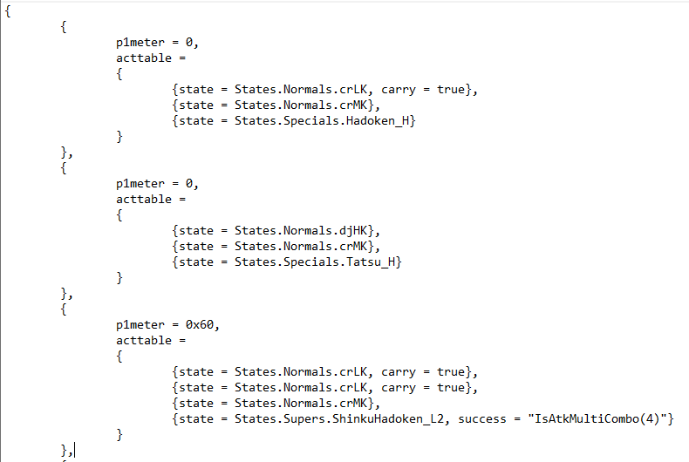
Each trial is itself a table comprised of the following parameters. Parameters in [] are optional. Additional game-specific parameters are defined in the game-specific documentation.
Parameter | Type | Description | Possible Values
acttable | Table of actions | The trial’s action table. See below | See below
[name] | String | The trial’s name. Displayed in the trial interface. | Any non-empty string. If not defined, will default to “Trial <number>”.
[description] | String | The description of the trial. Displayed in the graphical menu when hovering over the trial’s respective button. | Any non-empty string. If not defined, displays nothing.
[fail] | String (Lua function) | A piece of Lua code that defines the conditions for a trial to be considered failed, resetting your progress. | Any string containing a function to be returned by the script. If not defined, defaults to a specific condition defined in the additional trial functions for the specific game (usually triggers when a combo drops or becomes escapable).

A trial is made up of actions. An action is a condition that must be met before the player can move on to the next one, which usually means landing a particular attack. To complete a trial, the player must complete all of its actions in sequence. Most of the time this equates to landing a particular sequence of attacks.
Every action is comprised of the following parameters. Parameters in [] are optional. Additional game-specific parameters are defined in the game-specific documentation.
Parameter | Type | Description | Possible Values
state | State | The attack that must be landed to progress the trial. Very rarely this can be another thing like a jump or a freestyle action. | Must be a properly defined state.
[name] | String | The name displayed for that action in the trial interface. If defined, will take priority over the values defined in the character data, regardless of display settings. | Any non-empty string
[nameadd] | String | Additional text appended to the action’s name in the trial interface, regardless of display settings. Used to visually display additional conditions for landing an attack, such as a crossup or midair hit. | Any non-empty string
[success] | String (Lua code) | A piece of Lua code that defines the condition for an action to be considered successfully executed. | Any string containing a function to be returned by the script. If not defined, defaults to a specific condition defined in the additional trial functions for the specific game (usually triggers when the specific attack increments the combo counter).
[carry] | Boolean | If this is set to true, the next action in the list will be visually displayed on the same line as the one with the carry parameter. Does nothing if the config parameter AllowLineCarry is not set to true or if the action is the last action in the trial. Recommended to use for loops or chains of normal attacks. | true/false  Default: false

In order to set custom conditions for success & failure, use player variables and logical functions specific to each game.
Player Variables
Player variables are written in the following format: <player>.<time>.<variable>
<player> must be written as P1 or P2 without quotes, denoting which player the variable belongs to.
<time> must be the string “CurrState” or “PrevState”. The former denotes that the trial logic must check for the value on the exact frame the check is executed. The latter does so for the value exactly 1 frame before the check is executed. (For anyone coming from RetroAchievements: yes, these are the equivalent feature of delta values in RA’s toolkit).
<variable> must be a variable from the list of player variables, which can be found in the game-specific documentation.
Example: In Street Fighter Alpha 1, one of the available player variables is a boolean variable called “IsAirborne”. In order to enforce the requirement for hitting a mid-air opponent with an attack, you would write the following success condition: “IsAtkCombo() and P2.CurrState.IsAirborne”.
This condition is comprised out of two conditions which must both be true simultaneously for the action to count as successful. The first checks for incrementing the combo counter while a specific attack is in progress. The second uses the player variable “IsAirborne” to detect whether player 2 was airborne on the very frame the attack hits.
Examples (Street Fighter Alpha 1)
Example 1 (Ryu):
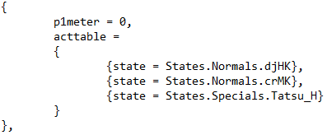
Diagonal Jump HK
Crouch MK
(H) Tatsumaki Senpukyaku
This is a basic jump-in combo with no additional flags. This sort of combo is the basis which you can use to build fancier trials.
Example 2 (Chun-Li):
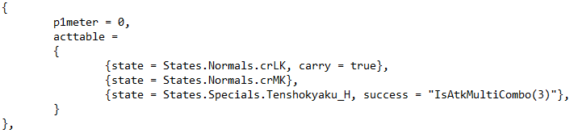
Crouch LK -> Crouch MK
(H) Tenshokyaku
cr.LK -> cr.MK is a chain combo. This trial has a carry flag on the first action, which causes the cr.MK to be visually displayed on the same line next to the cr.LK. The ender has a custom success condition requiring it to hit 3 consecutive times.
Example 3 (Charlie):
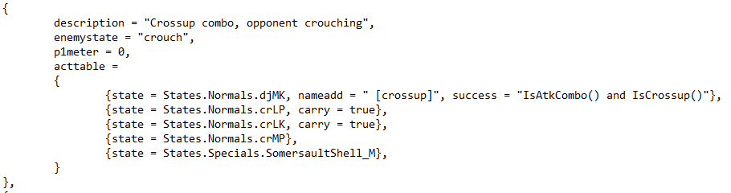
Diagonal Jump MK [crossup]
Crouch LP -> Crouch LK -> Crouch MP
(M) Somersault Shell
This combo starts with a crossup jumping MK – the opponent is set to crouch in order to let the player more easily land the crossup. A description is written to let the player know as much.
The first action has two additional parameters. First, the nameadd parameter is used to visually communicate that the attack must be a crossup. Next, a custom success condition is written – the attack must hit and increment the combo counter while simultaneously being a crossup.
The next three actions are a chain combo of three normal, displayed on the same line through the use of carry flags. The last action is the ender with no additional parameters.
Example 4 (Ken):
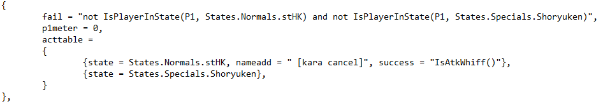
Stand HK [kara cancel]
Shoryuken
This trial requires you to cancel the startup of a normal move into a special. To enforce this, a custom fail condition is written where the trial resets if the player is not currently performing one of the two attacks. A custom success condition is written for the st.HK where merely starting its animation will count it as completed. The trial is completed once you successfully execute the kara cancel and the Shoryuken hits the opponent.
Example 5 (Rose):
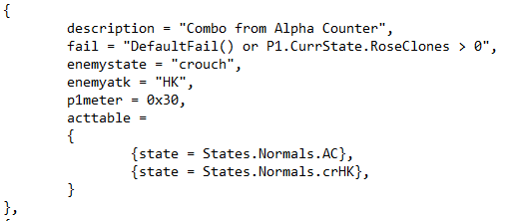
Alpha Counter
Crouch HK
This combo starts from Rose’s Alpha Counter. In order to let her land it, the enemy is set to repeatedly perform a cr.HK. A custom fail condition is written to block Rose from using her Soul Illusion super, which enhances her move properties and enables new combos.
Example 6 (Rose):
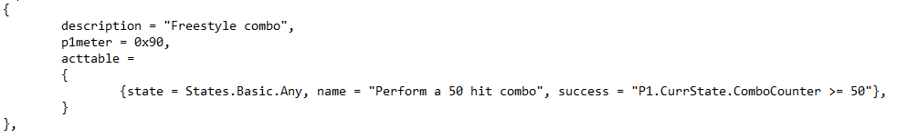
Perform a 50 hit combo
This is a freestyle combo that does not require landing any specific attacks. For this trial’s sole action, the state “Basic.Any” is used, which comprises the character’s entire state machine. The name parameter is used to forcibly overwrite the state’s name with the condition for completing the trial. This condition is then enforced through the success condition using the variable for player 1’s combo counter.
Testing Character States
The script includes an extension of Fightcade’s training mode to test character states.
In order to use it, do the following:
1. Backup Fightcade’s training mode folder in case anything goes wrong. It is located at “<Fightcade install dir>/emulator/fbneo/fbneo-training-mode”.
2. Copy the contents of the script’s “statetest” folder into Fightcade’s training mode folder.
3. Run Fightcade’s training mode with a game supported by the script.
If all goes well, you should see something like this:
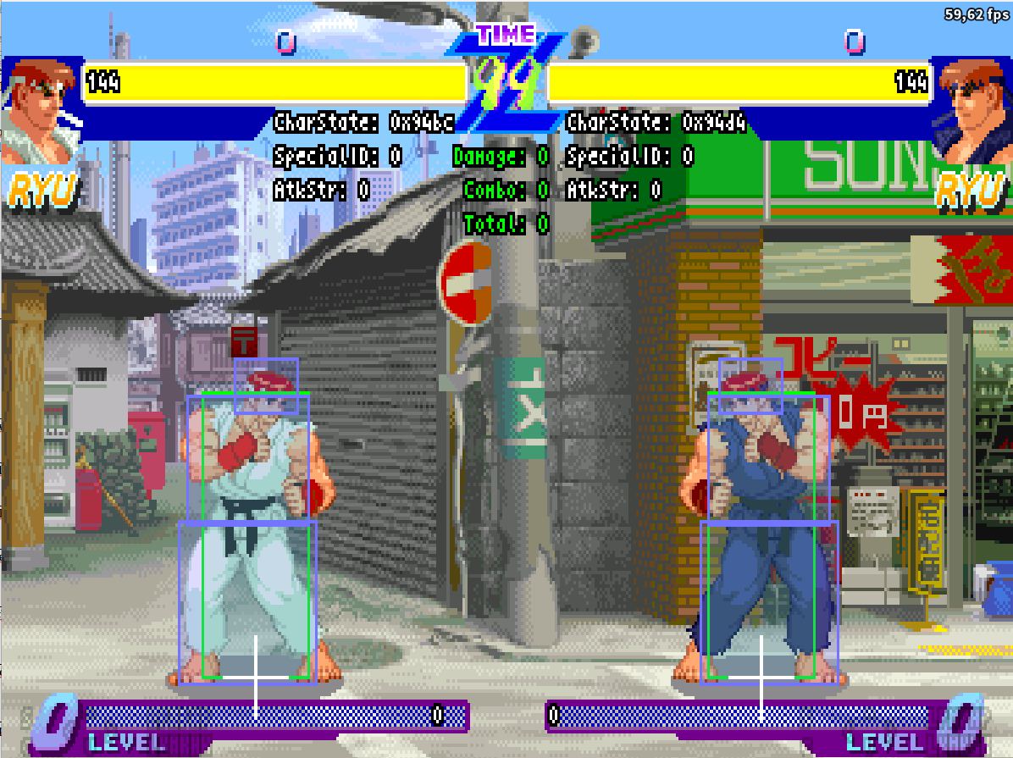
This extension modifies Fightcade’s training mode to display additional information about character states for each specific game. In the screenshot above, it shows the additional values for character data attributes for Street Fighter Alpha 1: the characters’ current states in both players’ respective state machine addresses, the current attack’s strength (light/medium/heavy) and the ID of the last used special/super move. These values are then used to fill out the character data files needed for the trials to function properly.
Some advice if you intend to help with this:
- Any time you’re testing a specific attack or other state, be sure to do so multiple times and record all possible values frame-by-frame. Even disregarding game-specific quirks like CPS2 frameskipping, some values may randomly appear for only 1-2 frames or not appear at all.
- If you already have existing data to go off of, pay attention to specific patterns and intervals between values. Do this for values belonging to a single action and values belonging to different actions. Take notes of how values for different attacks are grouped relative to each other. This will help you catch errors when testing states for other characters. Keep in mind these patterns should not be assumed to be 100% consistent, but they should repeat in most cases.
Example: in Street Fighter Alpha 1, character states are taken from a “state machine” address. Within a single action, state values are defined with an interval of 0x18. The end of one action differs from the beginning of the next action by an interval of 0x0b. This is true for most attacks, but differs massively for non-attacking states such as movement or hitstun.
Miscellaneous
- Player 2’s inputs are always frozen while the script is active. This is to simulate a completely immobile training dummy as is the case with most FG trial modes.
- For any games with stun (i.e. most Street Fighter games), the script forcibly prevents the opponent from ever being stunned. This is because being stunned immediately ends the combo (the opponent always has a chance to mash out).
- For any games with variable game speeds (i.e. Capcom games on CPS2 hardware), the script forcibly sets the game speed to the slowest possible. This is because the speed increases in those games are achieved through skipping frames at different intervals. A skipped frame will eat your input and will not be processed by the script. Among other things, this can randomly cause combos to drop and successful attacks to not count towards completing a trial. The slowest speed is used to minimize such occurences.

